Walk 38 Ledbury
Last walked in October 2016

Description. 7.5 km (4.6 miles). Walking from the centre of the delightful historic market town of Ledbury takes us past the church into Coneygrove Wood and over the hill to the tiny village of Eastnor, with its beautiful early 19th-century castle.
Start. The Market House, Ledbury. Explorer Map 190. Grid 711377.
Directions from Whitecross Roundabout (Turn milometer to zero). Take the A4110 Canon Pyne (Three Elms road) for 1 mile and TR at the traffic lights onto the A4103 Worcester (Roman road). After 7.7 miles TR, signposted to Stoke Edith. After 9 miles TL at road junction (not sign posted) onto main road to Ledbury. Reach roundabout at 15.9 miles and go straight across heading for the Town Centre. Go thru town centre and at 16.9 miles TR at the clock tower on the R (Bye Street), and continue on to the car park on your L.

1. Ledbury. Ledbury is an ancient borough, dating back to the Domesday Book, where it was recorded as Liedeberge, and returned members to Parliament in the reign of Edward I. Ledbury probably takes its name from the River Leadon, on which it stands. From the 17th century market house, which is across the road from the clock tower, walk up the cobbled road of Church Lane (not Church Street), to pass thru the church gates at the end of the lane. TR and go around the back of the church and along the narrow lane called Cabbage Lane, (on the L hand side is a police station) to reach the main road. TL here and once past the houses cross over the road to the narrow footpath heading up into Coneygree Wood. Climb slightly and when the path divides take the waymarked L fork (the R fork is the route of our return near the end of the walk). Climb steadily and go up steps to reach a broad horizontal track, cross this and keep straight ahead, taking the lower of the two tracks. After climbing some wooden steps you reach a track T-junction with a wide stony track which you go straight across and continue up a narrow path. Go thru a metal kissing gate into an open field {F1} where you TL. Stay close to the field margin as it bends to the R and then, when it bends again, go straight on to leave this field thru a wooden gate. Go on thru a few trees, descending slightly to go thru {F2} and continue on along the L hand border.

2. End of Field. At the end of the field go thru a kissing gate and thru a patch of trees as you climb slightly to be joined by a track coming in from the R. Continue in the same direction to the top of the hill, after which a slight descent and a bend to the L take us thru a metal gate and into {F3}. Continue along the track that crosses the middle of this open field and then go along a short track thru the woods and out into {F4}. Bear slightly L and follow the track down hill. The line of a farm track is our route down the hill, but when the track bends R we follow a way marker and keep straight ahead. Keep to a tree line on your R to reach the bottom R hand corner of the field where you go down some wooden steps and out onto the main road. TR, pass the church on your R, (well worth a visit), and then reach a small green, with its water fountain.

3. Eastnor. The road continues to the R past the water fountain on your L. TR up the driveway to Eastnor Pottery. Eastnor Castle was constructed between 1812-20 at a cost of £85,000 or equivalent to approximately between £6 to £28 million in present day (2007). The estate was started in the late 16th century when the Cocks family purchased local land. Pass the pottery and continue along the driveway and up along a stony track. Go past a military parade of tall trees on the R that seem to be in perfect alignment. When the track bends to the L you continue on for about 150m and then go thru a small metal gate on your R, into {F5}. Head diagonally to the L across the field and up to the far corner where you go thru the metal gate that’s to the R of buildings. Continue along the track for a short distance to reach the next metal gate, but don’t go thru it, TR along a narrow footpath that goes along the edge of the wood, after a short distance you go thru a wooden gate into {F6}. Go diagonally R, cross the field, heading for the bottom far R hand corner where you go thru a small wooden gate, over a plank of wood and thru another small wooden gate into the woods. Follow the indistinct path ahead that soon meets up with a more distinct track that goes up to meet a track junction at the edge of the trees, (a Forestry Commission notice board is on the L that says ‘Conigree Wood’).

4. Forestry Commission. TR, go up the track. When it levels off slightly at a cross paths, the main track keeps straight ahead, and rising, but we TL here. Follow the path leading thru to an old avenue of beech trees, and soon views over Ledbury begin to open up down to the L. After a slight rise the footpath divides and we take the L fork, keeping nearer the edge of the woods. A large grassy field slopes down to the town, and this is part of the former estate of Ledbury Park. Walk along the edge of the woods until the path broadens out and is floored by stone in places (some of which contains fossils). Continue along the broad track and stay close to a stone wall which appears on your L. You leave the broad track to take a narrow path that goes off to the L by the wall. Quite sunken, this path leads us down to join a path to the R, which was the route of our outward journey. But we keep straight ahead down a few small steps, to reach the road and TL back into Ledbury to the start of the walk.
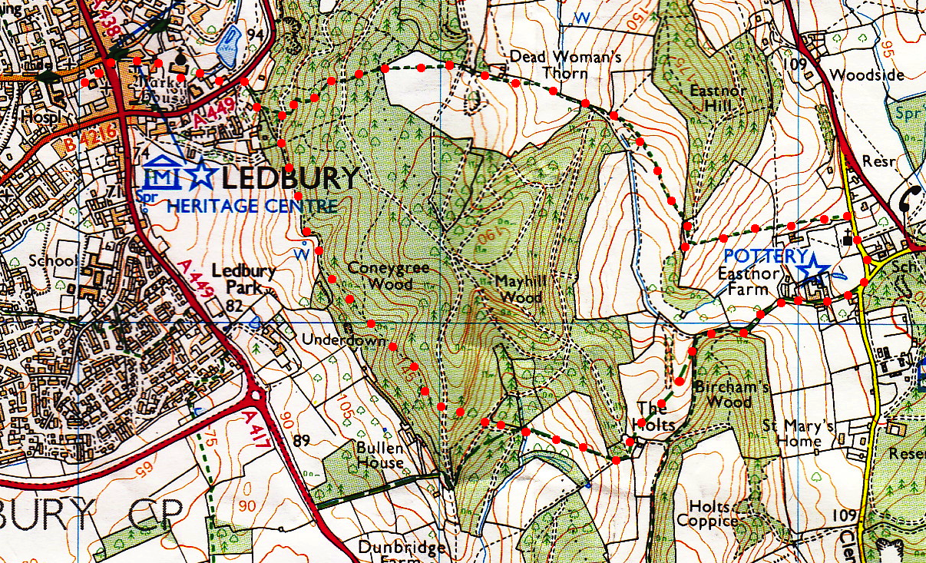
3
4
1
2

